# **CHAPTER 1: INTRODUCTION**

## **1.1 INTRODUCTION**

“Movie ticket booking system” is developed by using C++ language. It is developed to provide services for booking movie tickets and provide information about the movies and their schedule timing to the customers.

It provides another way for the customers to buy movie tickets. This system reduces work load on customers. This project is aimed to provide complete information of the movie and schedule to the customer, according to which they can book the tickets. The system allows the owner to keep track of available seats for a particular movie and even maintain various details of the audience. Viewers can view the movies which are being shown in the theatre or the ones which are going to be released for a short while along with their show timings and also book the tickets. Using this system, the owner doesn’t have to sit and manage the entire activity on paper. And at the same time, the Owner will feel comfortable keeping a check on the cinema.

It also calculates all the associated charges incurred in booking the tickets. User may even cancel the bookings that have been done before and can book for another one. This is an advanced booking system that makes user customize their show according to their needs. [1]

## **1.2 PROBLEMS STATEMENT**

In traditional way of booking the ticket for the movie the customer needs to go to the specific theatre where the desired movie was playing and need to stand in queue and buy the ticket for the movie which was difficult for the customers. It also required more human efforts to manage each and every aspect of customers details and was very costly process.

To overcome all kind of problems being faced by movie ticket booking processing we are developing this project. Our project “Movie Ticket Booking System” will provide efficient and faster services and always have possibilities of enhancement up any legal extent to satisfy user requirement.

## **1.3 OBJECTIVES**

The main objectives of the system are:

1. Allow customers to know about new movies, their schedules, ticket prices, booking status etc.
2. To manage the details of movie, ticket, customer, show timing.
3. To reduce the manual work for managing the movie, ticket booking, customer details etc.
4. Layout of seat status is visible to the customer and the customer and select his/her desired seat location and number of seats.
5. It tracks all the details of the customer, payment etc.
6. Provide information about up-coming releasing movies with their release date.
7. To minimize the number of staff at the ticket-box window in cinema hall.

## **1.4 SCOPE**

This project “Movie Ticket Booking System” has a wide scope as it can be easily used in any Movie ticket booking process with little changes. This project can save time and efforts in managing the records of customer, just a mouse click can make the task easy and faster. This Project has a lot of scope for future enhancement to benefit customer with efficient and faster services by integrating online payment with online booking and many other features such as searching the details of the particular customer etc.

1. Security of data
2. No need to do paper work
3. Better service
4. Minimize manual data entry
5. Minimum time required
6. Ensure data accuracy
7. Manage the information of the movie

## **1.5 ADVANTAGES**

The advantages of the system are listed below:

1. A modern approach to booking.
2. It calculates all the associated charges incurred in booking the tickets.
3. The owner doesn’t have to sit and manage the entire activity on paper.
4. It allows the owner to keep track of available seats for a particular movie and even maintain various details of the audience.
5. Admin can also add the details of the show and update the time and money according to his desire.
6. Editing, adding and updating of Records is improved which results in proper resource management of data.

## **CHAPTER 3: REQUIREMENT ANALYSIS AND IMPLEMENTATION**

## **3.1 SYSTEM REQUIREMENTS**

Following hardware and software requirement should be met for flawless running of this system:

**Hardware:** Hardware is the collection of physical parts of a computer system. This includes the

computer case, monitor, keyboard, and mouse. It also includes all the parts inside the computer

case, such as the hard disk drive, motherboard, video card, and many others. Computer hardware

is what you can physically touch.

RAM: 256 MB

Hard Disk: 200MB or above free space available

Processor: Intel Pentium III or higher

**Software:** Software is a set of instructions, data or programs used to operate computers and

execute specific tasks. It is the opposite of hardware, which describes the physical aspects of a

Computer.

OS: Windows 7 or Higher

Applications: Dev C++ or C++ compiler.

## **3.2 SYSTEM METHODOLOGY**

**WATERFALL MODEL**

The waterfall model is a classical model used in system development life cycle to create a system with linear and sequential approach. It is termed as waterfall because the model develops systematically from one phase to another in a downward fashion. In waterfall model the requirements are very well documented, clear and fix. The project done under waterfall model is short and the product definition is stable. [2]

The sequential phases described in the Waterfall model are:

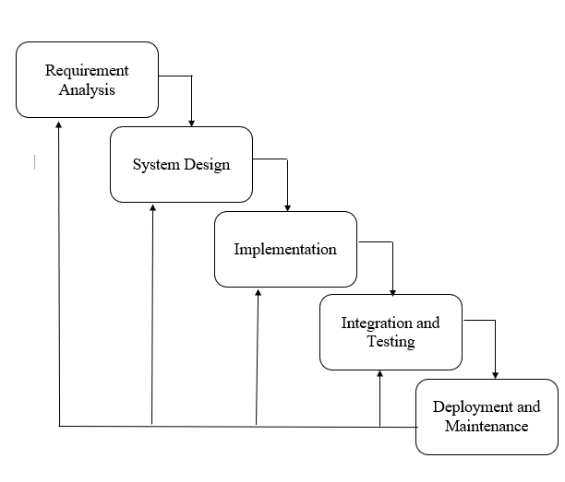

Figure 1: waterfall model [4]

**1. REQUIREMENTS ANALYSIS**

The requirements of clients are:

1. To minimize the number of staff at the ticket box window.
2. Movie ticket booking system should provide another way for the customers to buy movie ticket. This system should reduce work load on Customers.
3. File handling should be used.
4. Customer logins to the system by entering valid username and password.
5. There should be a screen displaying information about the upcoming movies along with their actual release date.

**2. SYSTEM DESIGN**

System design is the process of designing the architecture, components, and interfaces for a system so that it meets the end-user requirements. A good system design is to organize the program modules in such a way that are easy to develop and change. There are many strategies or techniques for performing system design.

Importance:

1. If any pre-existing code need to be understood, organized, and pieced together.
2. It is common for the project team to have to write some code and produce original programs that support the application logic of the system.

**3. IMPLEMENTATION**

This phase is initiated after the system has been testes and accepted by the user. System performance is compared to performance objectives established during the planning phase. System implementation is a process of ensuring that the information system is operational. Implementation allows the users to take over its operation for use and evaluation.

Implementation includes user notification, user training, installation of hardware, installation of software onto production computers, and integration of system into daily work processes. This phase continues until the system is operating in production in accordance with the defined user requirements.

1. We used C++ programming to implement our project.
2. File Handling was used for the data and records.
3. Functions for sub modules.
4. The system is first developed in small programs called units, which are integrated in the next phase. The testing of each developed unit individually is referred as unit testing.

**4. INTEGRATION AND TESTING**

The systems integration test function is to ensure that the developed systems meet all the technical requirements with the components and subsystems integrated. All the modules/functions are tested. Individual functions are provided and output is generated. The code is tested through the unit testing.

Unit testing:

A testing technique using which individual modules are tested to determine if there are any issues to be fixed. It is concerned with functional correctness of the standalone modules. The main aim is to isolate each unit of the system to identify, analyze and fix the defects.

Advantages of unit testing

1. Reduces defects in the newly developed features or reduces bugs when changing the existing functionality.
2. Reduces Cost of testing defects are captured in very early phase
3. Improves design and allows better refactoring of code.

**5. DEPLOYMENT AND MAINTENANCE**

1. The deployment phase is the final phase of the software development life cycle (SDLC) and puts the product into production.
2. After the project team tests the product and the product passes each testing phase, the product is ready to go live. This means the product is ready to be used in a real environment by all end users of the product.
3. Once the functional and non-functional testing is done, the product us deployed in the customer environment or released into the market.
4. After the product is deployed to the user’s market from there the maintenance phase starts
5. Once the product or the system is in use there will be many patches to be fixed.
6. The user might ask for new features and enhancements. It is the responsibility of the maintenance team to attend to these requests and to fix the bugs that are found.
7. The maintenance effort revisits all the other stages of the software life cycle.
8. Each modification requires planning, specification, design, coding, testing, installation.

**FUNCTIONAL REQUIREMENT**

In software and system engineering, a functional requirement defines a function of a system or its component, where a function is described as a specification of behavior between input and outputs.

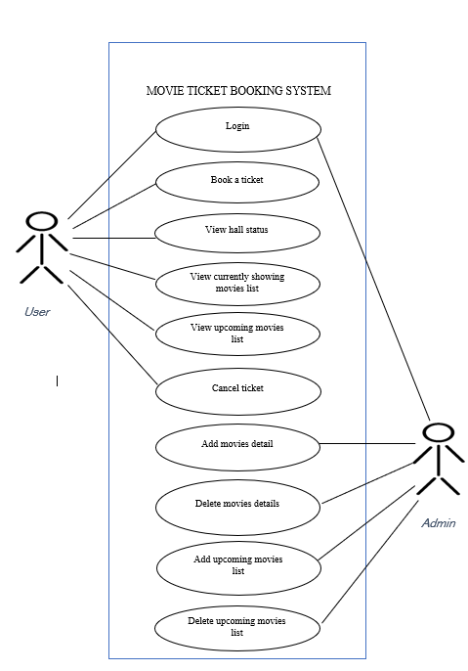

# **CHAPTER 4: CONCLUSION AND FUTURE SCOPE**

## **4.1 CONCLUSION**

The entire project has been developed and deployed as per the requirements stated by the user, it is found to be bug free as per the testing standards that is implemented. The main objective of the **Movie Ticket Booking System** is to **manage the details of Seat, booking, Customer, payment, Shows**. Use of this interface helps customers in having immediate information about running movies and reserve their seat without wasting their precious time.

Hence this system will help in reducing the labor and provide more facility for viewers who will increase their level of ease.

However, it is not a complete system and there are many further improvements that can be done to make it more user-friendly and easier to access and use. Also adding additional features to make it more effective and efficient.

At the end it is concluded that we have made effort on following points

1. We define the problem on which we are working in the project.
2. We describe the requirement Specifications of the system and the actions that can be done on these things.
3. The description of Purpose, Scope, and applicability.
4. Finally, the system is implemented and tested according to test cases.

## **4.2 FUTURE SCOPE**

Our project is only a humble venture to satisfy the needs to manage the project work. The system right now is a simpler version so it lacks advanced features and is limited in some aspects. Several user-friendly coding has been adopted. But still, we think that our system has potential to grow. Some of the future implementations of “**MOVIE TICKET BOOKING SYSTEM**” are as follows:

1. The interface can be enhanced so that it looks more attractive and interactive.
2. Online booking can be made possible.
3. Acceptance of online payment.
4. Pre-booking of upcoming movies can be done.
5. Online viewing of available seat information
6. Online Ticket cancelation capability

# BIBILOGRAPHY

|  |  |
| --- | --- |
| [1] | K. Ratik, "academia.edu," 12 03 2014. [Online]. Available: https://www.academia.edu/36099864/Online_Movie_Ticket_Booking_System. [Accessed 05 01 2022]. |
| [2] | R. S. .. Pressman, Software Engineering A Practitioners Approach, Singapore: MeGraw-Hill, 1997. |
| [3] | E. Balagurusamy, Programming in ANSI C, Tata Mc Graw-Hill publishing.. |
| [4] | J. A. Hoffer, Modern System Analysis and Design, Benjamin-Cummmings Pub Co, May 1 , 1996. |